Warwick Pond

Lockwood
Brook

Buckeye Brook
Old
Mill
Cove

Warner Brook

Watershed Watch Sampling Sites for Buckeye Brook Watershed

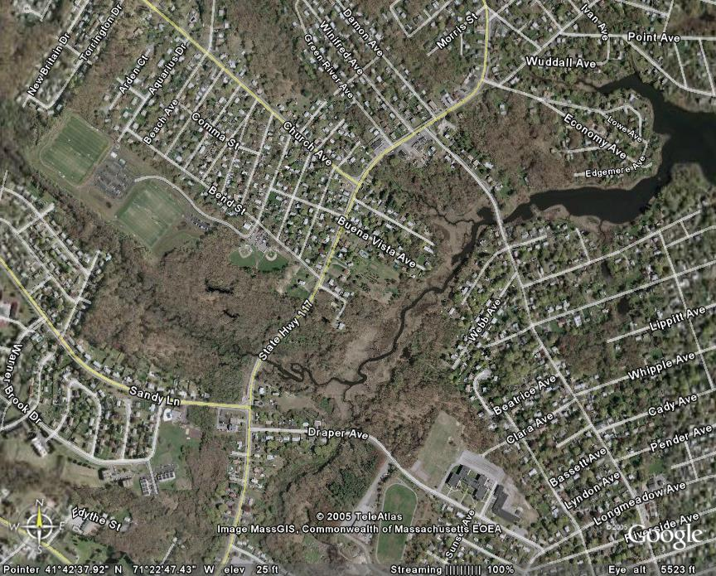
Buckeye@ Novelty Rd
Buckeye@ Warner Rd
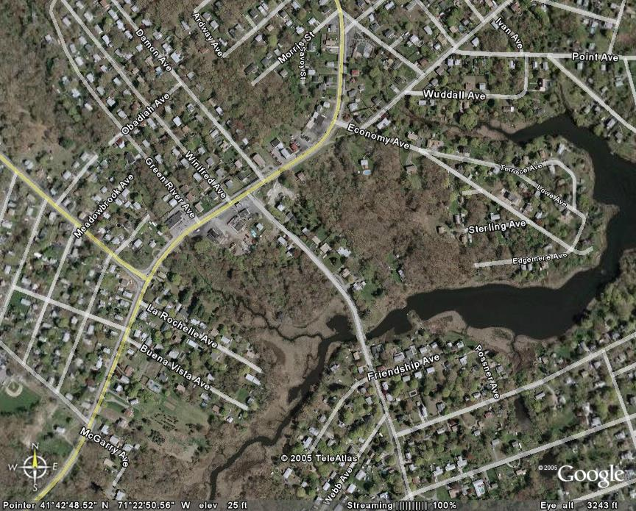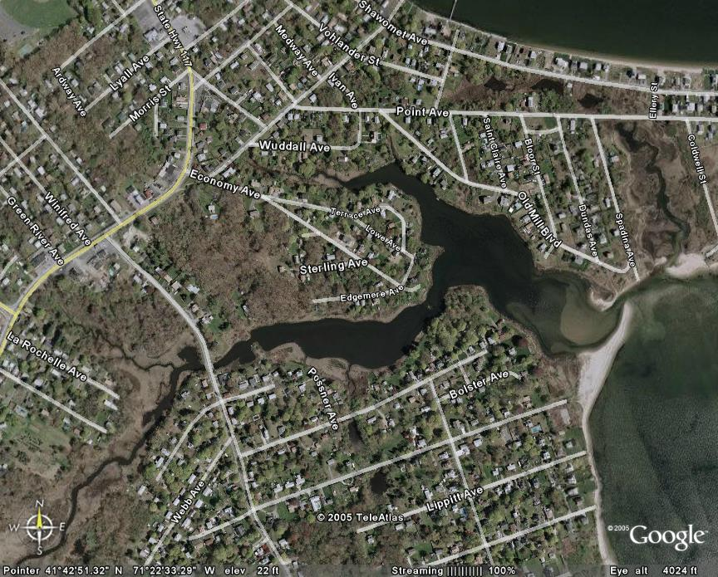
Buckeye@ Lockwood Bk
Buckeye@ Mill Cove
Old Mill Cove
Buckeye Bk
Lockwood Bk

