VOLUNTEERS NEEDED!!
HISTORICAL CEMETARY CLEAN-UP
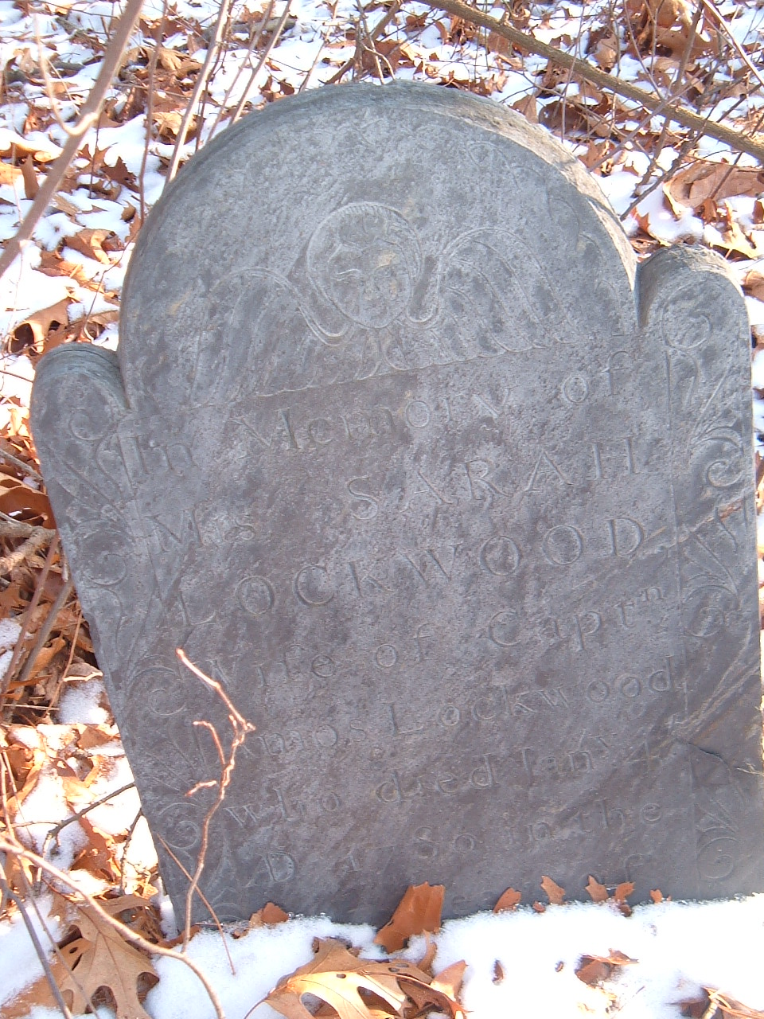
Come Help!
- Date: Saturday, January 14, 2006.
- Time: 9:00Am.
- Place:Warwick K of C Parking Lot.
Dress for the Weather! please bring Pruning Shears, Saws and Metal Rakes.

Sponsored By: The Buckeye Brook Coalition, The Warwick Histstrical Cemetery Committion, and the Warwick Knights of Columbus, Council 2295.
More Info: Steve Insana @ 737-1342.

