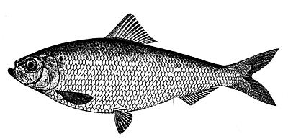

Buckeye Brook Coalition

Fall 2011 Fundraiser

Sunday, September 18, 2011

4 p.m. to 6 p.m.

15 River Vue Avenue, Warwick

Please join the Buckeye Brook Coalition and help raise funds
to protect and preserve your local watershed.

Come enjoy burgers, hot dogs, soft drinks, desserts & music at the home of
Mr. & Mrs. George W. Shuster, Jr. on the south bank of Mill Cove.

$10 for BBC members / $15 for non-BBC members
Free for children under 12

Tickets available at the event, or reserve in advance by reply to Stephanie Van Patten: 401.737.1278 / slvp21@gmail.com

